project management plan

for the

FaShion store website

**20/10/2016

Team Number: 12

Team Member: Salma Mohamed Yassin - 133722

# SECTION 3. MANAGEment PROCESS

## 3.1 Start-up

**3.1.1 Estimation**

### Functions:

1. Uses the website to view available products through different categories
2. Tracks the sold products to insure their availability in the inventory

**Size Estimation:**

1. **Uses the website to view available products through different categories:**

In Fashion Store website the customer can enter which category he/she wants to shop or browse from then all of the items will be displayed in front of the customer with their names, descriptions, prices, sizes, colors, details and whether they are in stock or not so that the customer can browse through them freely with everything clearly displayed for him/her.

**External input types (EI):** 1 input (Category)

**Record Types:** 1 Record type – Category table

**Data Types:** 1 Data Types – Category Name

**Complexity:** Low = 3

**External output types (EO):** 1 Report

**Record Types:** 2 Record Type – Products table, Inventory table

**Data Types:** 6 Data Types – Product Name, Product Description, Product Price, Product Color, Product Details, In-Stock

**Complexity:** Average = 5

**External inquiry types (EQ):** None

**Logical internal file types (ILF):** 1 internal database

**Record Types:** 1 Record Type – Products table

**Data Types:** 5 Data Types – Product Name, Product Description, Product Price, Product Color, Product Details

**Complexity:** Low = 7

**External Interface Files (UI):** 1 database (Inventory)

**Record Types:** 1 Record Type – Inventory table

**Data Types:** 1 Data Type – In-Stock

**Complexity:** Low = 5

**Total size =** (3*1) + (5*1) + (7*1) + (5*1) = 20 FP x 60 = 1200 LOC = 1.2 KLOC

(MVC .NET <http://www.qsm.com/resources/function-point-languages-table>)

1. **Tracks the sold products to insure their availability in the inventory:**

One of the main admin functions of the Fashion website is to track sold products of the site to insure their availability in the inventory, a program needed to extract the number of sold products from the sold items file and the details for each item and the remaining number of that item in the inventory. The program will produce a record showing for each item the number sold and the number which is still in the inventory.

**External input types (EI):** None

**External output types (EO):** 1 report

**Record Types:** 3 Record Types – Products table, Sold Products table, In-stock table

**Data Types:** 4 Data Types – Product Name, Product ID, Number Sold, Number In-Stock

**Complexity:** Low = 4

**External inquiry types (EQ):** None

**Logical internal file types (ILF):** 2 internal databases

**Record Types:** 2 Record Types – Products table, Sold Products table

**Data Types:** 3 Data Types – Product ID, Product Name, Number Sold

**Complexity:** Low = 7

**External Interface Files (UI):** 1 database (Inventory)

**Record Types:** 1 Record Type – Inventory table

**Data Types:** 1 Data Type – In-Stock

**Complexity:** Low = 5

**Total size =** (4*1) + (7*2) + (5*1) = 23 FP x 60 = 1380 LOC = 1.38 KLOC

(MVC .NET <http://www.qsm.com/resources/function-point-languages-table>)

**Effort Estimation:**

1. **Uses the website to view available products through different categories:**

**Exponent driver rating:**

**Precedentedness (PREC):** Low: 4.96, Most of the websites which sells products have this have the customers view their products so this function is similar to other previously designed ones.

**Development Flexibility (FLEX):** Low: 4.05, it is very flexible there are a lot of ways that the products could be displayed for the user in

**Architecture / Risk reduction (RESL):** Nominal: 4.24, The function is clear but a few changes can be made to the function so that it can look new in the site

**Team cohesion (TEAM):** Very Low: 5.48, The team members are very close to each other, they works together on a lot of projects

**Process maturity (PMAT):** Extra High: 0.00, The project is very organized and structured, nothing can go wrong hopefully

**Exponent Multiplier:**

**Product:**

**RELY:** High: 1.10, The database of the products of the Fashion store constantly changes and there is a small chance that a new product will not show in a specified category

**DATA:** Very High: 1.28, The database size for this function is very big due to the constant added products of the store to the site

**DOCU:** High: 1.11, The function matches the life cycle needs as it shows the customer the products in the categories of the site

**CPLX:** Very Low: 0.73, The function complexity is very low it is just displays the products for the customer to browse from

**REUSE:** High: 1.07, This function can be reused again in many sites that sells products online because it shows the items of the products the site have to offer to the customer

**Computer:**

**TIME:** Nominal: 1.00, The time is very precise in this project because it takes a lot of time to upload new products to the site

**STOR:** High: 1.05, A big storage is needed so that all the products of the site can be placed on the website

**PVOL:** Nominal: 1.00, it is not very volatile because it contains lots of pictures for the displayed products

**Personnel:**

**ACAP:** Very High: 0.71, The Analysts are very cooperative and efficient

**AEXP:** Very High: 0.81, The team working on the site is very skilled in testing applications similar to this one so they will be very precise when testing this one

**PCAP:** Very High: 0.71, The team working on the site will be interviewed to insure that their capabilities meets the project’s requirements

**PEXP:** Very High: 0.85, The team working on the project must be familiar with the platform while testing the function

**LEXP:** Very High: 0.84, The team working on the project will be

interviewed to insure that they are very skilled with the computer language needed to test the functions

**PCON:** Nominal: 1.00, The Website needs to always be updated with

new the store’s new products but can also displays older ones

**Project:**

**TOOL:** High: 0.90, The website will use a lot of software so this function may use these software used in the website

**SITE:** Very High: 0.86, The team can handle working on multiple sites

at the same time

**SCED:** Very High: 1.00, The team working on the project will divide

their time perfectly

A = 2.94

B = 0.91

Size = 1.2 KLOC

Sum of exponent driver rating = 4.96 + 4.05 + 4.24+5.48+0.0 = 18.73

Product of exponent driver rating = 1.10 * 1.28 * 1.11 * 0.73 * 1.07 *1.00 * 1.05 * 1.00 * 0.71 * 0.81 * 0.71 * 0.85 * 0.84 * 1.00 * 0.90 * 0.86 * 1.00 = 0.2892

Sf = B + 0.01* Σ(exponent driver ratings) = 0.91 + (0.01 * 18.73) = 1.0973

Effort (PM) = A(Size)^sf x (Product of exponent multipliers) = 2.94(1.2) ^1.0973*(0.2892) = **1.0385**

1. **Tracks the sold products to insure their availability in the inventory:**

**Exponent driver rating:**

**Precedentedness (PREC):** Low: 4.96, Most of the websites which sells products tracks their sold to insure their availability in their inventory

**Development Flexibility (FLEX):** Very High: 1.01, The function to check the inventory is only developed in one or two ways

**Architecture / Risk reduction (RESL):** Low: 5.65, The function is certain and very few changes can be made to the function

**Team cohesion (TEAM):** Very Low: 5.48, The team members are very close to each other, they works together on a lot of projects

**Process maturity (PMAT):** Extra High: 0.00, The project is very organized and structured, nothing can go wrong hopefully

**Exponent Multiplier:**

**Product:**

**RELY:** VeryHigh: 1.26, The function needs to be reliable as possible to insure that the displayed store’s products for the customer is in-stock or not

**DATA:** Very High: 1.28, The Database is big due to the number of products in the inventory, and the number of products sold

**CPLX:** Low: 0.73, The function complexity is low because it only tracks the sold products to insure their availability in the inventory

**REUSE:** Nominal: 1.00, This function is not very reusable in many sites

**Computer:**

**TIME:** Nominal: 1.00, The time is very precise in this function because it takes not so much time to see the which items in-stock and which are not

**STOR:** Nominal: 1.00, The function only produces a report of which items are in-stock

**PVOL:** Nominal: 1.00, it is volatile because it goes through the sold products and the inventory only

**Personnel:**

**ACAP:** Very High: 0.71, The Analysts are very cooperative and efficient

**AEXP:** Very High: 0.81, The team working on the site is very skilled in testing applications similar to this one so they will be very precise when testing this one

**PCAP:** Very High: 0.71, The team working on the site should be interviewed to insure that their capabilities meets the project’s requirements

**PEXP:** Very High: 0.85, The team working on the project must be familiar with the platform while testing the function

**LEXP:** Very High: 0.84, The team working on the project should be

interviewed to insure that they are very skilled with the computer language needed to test the functions

**PCON:** Nominal: 1.00, The Website needs to always be updated with

new the store’s new products but can also displays older ones

**Project:**

**TOOL:** High: 0.90, The website will use the software to test this function.

**SITE:** Very High: 0.86, The team can handle working on multiple sites

at the same time

**SCED:** Very High: 1.00, The team working on the project will divide

their time perfectly

A = 2.94

B = 0.91

Size = 1.2 KLOC

Sum of exponent driver rating = 4.96 + 1.01 +5.65+5.48+0.0 = 17.1

Product of exponent driver rating = 1.26 * 1.28 * 0.73 *1.00 * 1.00 * 1.00*1.00*0.71*0.81 *0.85*0.84*1.00*0.90 * 0.86*1.00= 0.2892

Sf = B + 0.01* Σ(exponent driver ratings) = 0.91 + (0.01 * 17.1) = 1.081

Effort (PM) = A(Size)^sf x (Product of exponent multipliers) = 2.94(1.2) ^1.0973*(1.081) = **3.729**

## 3.2 Work Planning

### 3.2.1 Work Activities (WBS)

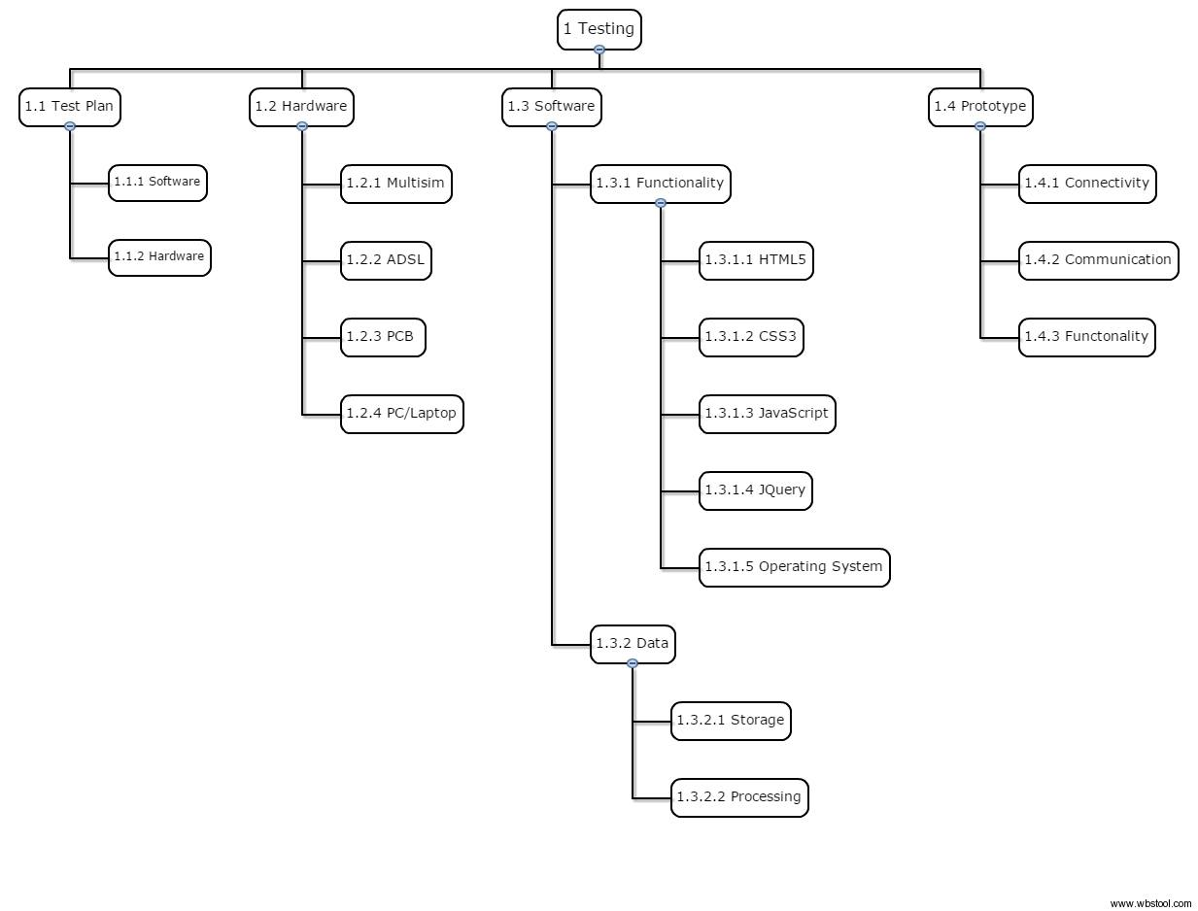

### 3.2.2 Resource Allocation

* Hardware needed: Multisim, ADSL, PCB, and a PC or a Laptop
* Software needed: HTML5, CSS3, JavaScript, JQuery, and an Operating System
* 4 Quality assurance are needed to test out those two main functions of the system; To display the site’s products through different categories of the site and for the admin to track the sold items to insure their availability in the inventory
* A meeting place for the testing team to meet and work together